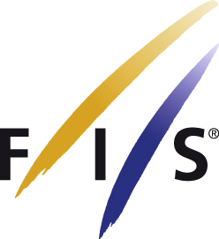
FIS Latvijas nacionālo čempionātu snovbordkrosā
SBX NC SPIDER WOMEN

DATE: 1.2.2009
PLACE: Cesis, Ozolkalns, LAT COMPETITION JURY Technical delegate: Lenka Kudlackova
Codex no.:7584 Chief of the race: Agris Raugulis
Finish referee: Iveta Gutmane

 |  | Semi final
From | Bib |  |  |  |  |  | Final
1 | 1 | Sproģe Anda | 1 |  | Bib
3 | 3 | Mieze Madara | 2 |  | 1 | Sproģe Anda |  | 1
5 | 5 | Drande Linda | 3 |  | 3 | Mieze Madara |  | 3
 |  |  |  |  | 2 | Valdusa Signe |  | 2
From | Bib |  |  |  |  | Small Final
2 | 2 | Valdusa Signe | 1 |  | 5 | Drande Linda |  | 2
4 | 4 | Bezbaile Kristine | 2 |  | 4 | Bezbaile Kristine |  | 1

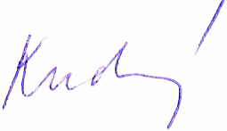
2143 Kudlackova Lenka

